**Fujitsu VF60 displays aka Giraffes**

Fujitsu VF60 Line Display from the Fujitsu OPOS system. Inside the VFD 20x2 from Futaba, model M202LD12A.  
Probably the cheapest (used) VFD display available on a well-known auction site.

[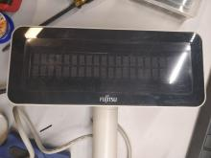](https://phabricator.hskrk.pl/file/data/k32dawee5z53mxotvola/PHID-FILE-zit7xpjsmi6u4trqeqwy/IMG_20190126_011708.jpg)

[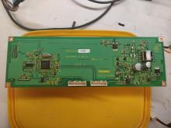](https://phabricator.hskrk.pl/file/data/xpjgkjkadfbzmzlvfn2o/PHID-FILE-edpfvwfr5bxjxjbvmbcm/IMG_20190126_013629.jpg)

Nominally at 12V, at 9V it also works, you can check below. The performance of the 3.3V stabilizer allows you to simultaneously power the display logic and any ESP8266 glued to it.

left connector - power + RS232  
right connector - power + serial over USB after a very strange driver

On the "TXD / RXD" pads present on the PCB, the serial port is 3.3V (it may be necessary to remove the MAX3232 next to it).  
Communication on 9600 8N1.

Configurator + USB driver (32-bit Windows) available at:  
<http://www.fujitsu.com/us/support/solutions/industry/retail/peripheral-drivers/>

**VF60.zip**2 MB[**Download**](https://phabricator.hskrk.pl/file/download/pqftfaqjf4lac55dc3sr/PHID-FILE-dblnggbrf3vzeee6h5pl/VF60.zip)

Documentation from a completely different display, but some commands match:  
<https://sourceforge.net/p/chromispos/discussion/general/thread/383efb0b/c7e6/attachment/EjN-ST-A10_LIUST-5X_CustomerDisplay.pdf>

**EjN-ST-A10_LIUST-5X_CustomerDisplay.pdf**1 MB[**Download**](https://phabricator.hskrk.pl/file/download/tfi54za2ilzzhhyyh2wz/PHID-FILE-d6upwrv4k6tzl23u5osr/EjN-ST-A10_LIUST-5X_CustomerDisplay.pdf)

In the case of direct control (omitting the Renesas character generator), a single "character" is 8x5 px.  
It is necessary to raise the control lines (BK / CLK / SI / LAT) before starting the converter (driving the Q7 transistor), otherwise the display will all light up and the converter will turn off.

Sending 0x 00001 000 0000 0000 046 3F8C 62E0 00001 causes displaying the letter A in the first position (last 5 nibbles) of the top line, and erasing the first position (first 5 nibbles) of the bottom line. A bitmasked item.

[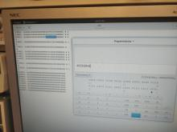](https://phabricator.hskrk.pl/file/data/ci3olt3esdp5izxbasn5/PHID-FILE-qbvehtr4pdhzcfzdjtxw/photo_2019-01-26_03-46-40.jpg)

The connectors are Molex Mini-SPOX pitch 2.5mm 5264-08 and 5264-09

(or just a 2.54 female header)

I connected the 8-pin connector CN1 as follows:

Pin 1 free

Pin 2 USB D+

Pin 3 USB D-

Pin 4 free

Pin 5 USB Gnd

Pin 6 +12V (power supply)

Pin 7 +12V (power supply)

Pin 8 Gnd (power supply)

Fujitsu VF60 Line Display from the Fujitsu OPOS system. Inside VFD 20x2 from

Futaby, model M202LD12A.

Probably the cheapest (used) VFD display available on the

known auction site is available.

Nominal at 12V, works at 9V too, you can check below.

The efficiency of the 3.3V stabilizer allows simultaneous

Powering the logic of the display and all the [ESP8266 attached](https://www.mikrocontroller.net/part/ESP8266) to it .

left connector - power supply + RS232

right connector - power + serial via USB after a very strange one

driver

For the "TXD/RXD" pads present on the board, the

3.3V serial port (may need the [MAX3232](https://www.mikrocontroller.net/part/MAX3232) next to it

be removed).

Communication on 9600 8N1.

Configurator + USB driver (32-bit Windows) available at:

<http://www.fujitsu.com/us/support/solutions/industry/retail/peripheral-drivers/>

Download VF60.zip 2MB

Documentation from a completely different display, but some commands

agree:

<https://sourceforge.net/p/chromispos/discussion/general/thread/383efb0b/c7e6/attachment/EjN-ST-A10_LIUST-5X_CustomerDisplay.pdf>

Download EjN-ST-A10_LIUST-5X_CustomerDisplay.pdf 1MB

For direct control (bypassing the Renesas character generator)

has a single "character" 8 x 5 pixels.

Before starting the inverter (controlling the Q7 transistor) must

the control lines (BK *CLK* SI / LAT) are raised, otherwise the

indicator lights up fully and the inverter is switched off

becomes.

When sending 0x 00001 000 0000 0000 046 3F8C 62E0 00001 the

Letter A in the first position (last 5 half bytes) of the upper

Line displayed and the first position (first 5 half bytes) of the lower one

row deleted. Position in the form of a bit mask.

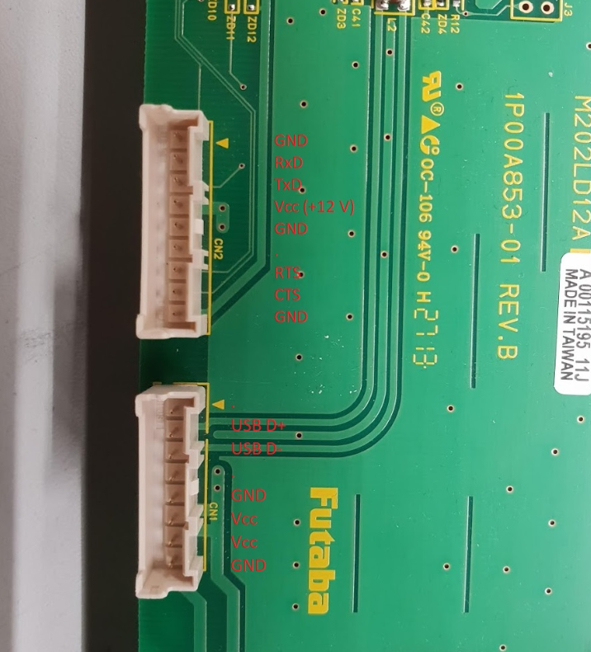

<https://github.com/ggajoch/vf60-vfd-display>

I ordered one from Max, but it's not there yet. Because of this

I haven't been able to look in yet. But I'm assuming that it is

VFD itself is of the dumb variety. And a µC in there controls it

and speaks either USB or RS-232 on the other side. the

Control codes (ESC sequences) are likely to be (a subset of) VT100. Of the

for "clear screen" fits in any case:

<https://de.wikipedia.org/wiki/VT100>